CSE 3212
Numerical Method

Assignment 02

1.Bisection method
2. False position method
3. Newton-Raphson method
4. Secant Method

Submitted by:
Name: Md. Musfiqur Rahman
Roll: 05

Problem 1

The velocity v of a falling parachutist is given by
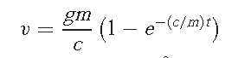
where g = 9.8 m/s2. For a parachutist with a drag coefficient c = 15 kg/s, compute the mass m so that the velocity is v = 35 m/s at t = 9 s.
By using
(a) bisection
and (b) false position.

Solution:

#include<stdio.h>
#include<math.h>
#include<bits/stdc++.h>
using namespace std;

void print(double v1, double v2, double v3, double v4, double v5, double v6)
{
cout<< "|" << setw(15) << v1 << "|" << setw(15) << v2 << "|" << setw(15) << v3 << "|" << setw(15) << v4 << "|" << setw(15) << v5 << "|" << setw(15) << v6<< "|" <<endl;
for(int i=0; i<100-4; i++)
printf("-");
puts("");
}

void print(string v1, string v2, string v3, string v4, string v5, string v6)
{
cout<< "|" << setw(15) << v1 << "|" << setw(15) << v2 << "|" << setw(15) << v3 << "|" << setw(15) << v4 << "|" << setw(15) << v5 << "|" << setw(15) << v6<< "|" <<endl;
for(int i=0; i<100-4; i++)
printf("-");
puts("");
}

double g=9.8, v=35, t=9, c=15;
double f(double m)
{
double r= g*m * (1 - exp(-(c/m)*t));
r=r/c -v;
return r;
}

void doBisection(double lo, double hi, double prec)
{

printf("Solving with Bisection method\n\n");
int iter=0;
double past=0, cur=0,mid;
print("iteration", "Upper value", "Lower value", "Xm", "f(Xm)", "Relative error");
while(1)
{
past=mid;
mid=(lo+hi)/2;
double r=f(mid);
if(f(mid)*f(lo)>0)
lo=mid;
else if(f(mid)*f(hi)>0)
hi=mid;

double rerror= fabs(mid-past)/mid;
// printf("iteration=%d Upper value=%.4f Lower value=%.4f Xm=%.4f f(Xm)=%.4f error=%.4f\n",++iter, hi,lo,mid,f(mid), rerror);
print(++iter, hi,lo,mid,f(mid), rerror);
if(rerror<prec) break;
}
printf("root=%.4f\n",mid);
}

double find_point(double x0, double x1)
{
double r= (f(x0)*(x1-x0))/(f(x0)-f(x1)) + x0;
return r;
}

void doFalsePosition(double lo, double hi, double prec)
{
printf("\n\n\nSolving with FalsePosition method\n\n");
int iter=0;
double past=0, cur=0,mid;
print("iteration", "Upper value", "Lower value", "Xm", "f(Xm)", "Relative error");
while(1)
{
past=mid;
mid=find_point(lo,hi);
double r=f(mid);
if(f(mid)*f(lo)>0)
lo=mid;
else if(f(mid)*f(hi)>0)
hi=mid;
double rerror= fabs(mid-past)/mid;
// printf("iteration=%d Upper value=%.4f Lower value=%.4f Xm=%.4f f(Xm)=%.4f error=%.4f\n",++iter, hi,lo,mid,f(mid), rerror);
print(++iter, hi,lo,mid,f(mid), rerror);
if(rerror<prec) break;
}
printf("root=%.4f\n",mid);
}

void printLowToHigh(double a, double b)
{
for(double i=a; i<=b; i+=0.1)
{
cout<<i<<" "<<f(i)<<endl;
}
puts("");

}

int main()
{
printf("Maximize the screen\n");
double lo=-100, hi=0, prec;
printf("lower limit:");
cin>>lo;
printf("higer limit:");
cin>>hi;
printf("tolerance:");
cin>>prec;
printLowToHigh(lo,hi);
if(f(lo)*f(hi)>0)
{
printf("No root is possible\n");
return 0;
}
doBisection(hi,lo,prec);
doFalsePosition(hi,lo,prec);
}

Sample input:
lower limit:50
higer limit:60
tolerance:0.00001

Sample output:

Snapshot 1 :

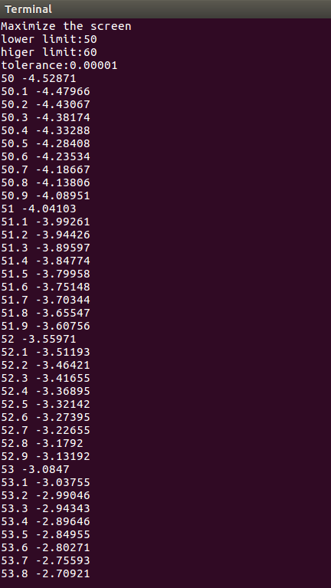
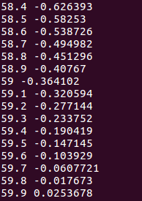
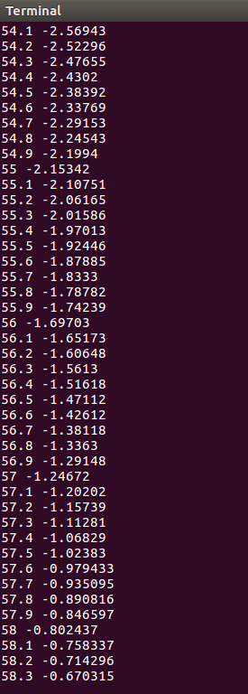

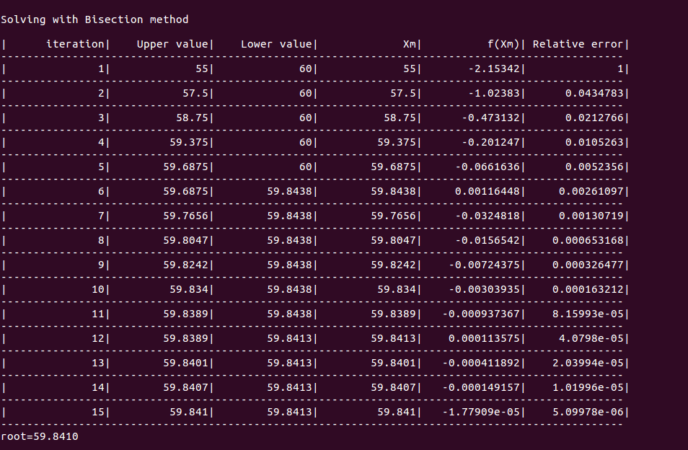
Snapshot 2 :
Snapshot 3:
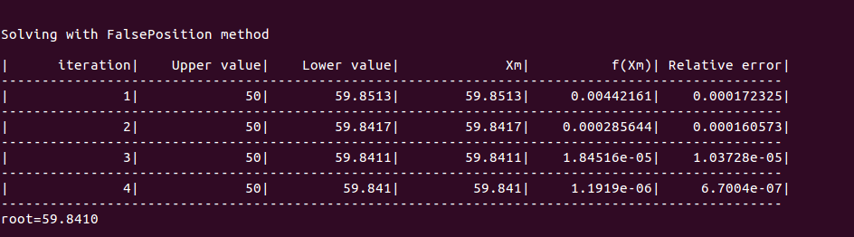

Graphs:

Graph1: The graph of xm and relative approximation error (bisection).
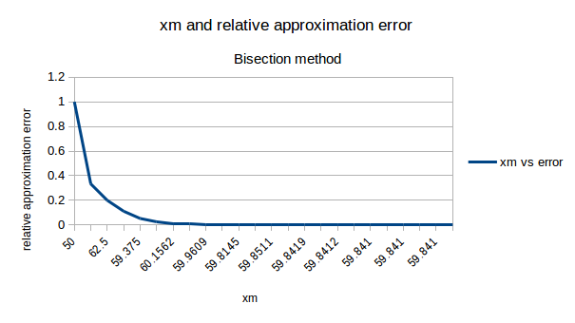

Graph2: The graph of no of iteration and relative approximation error (bisection).
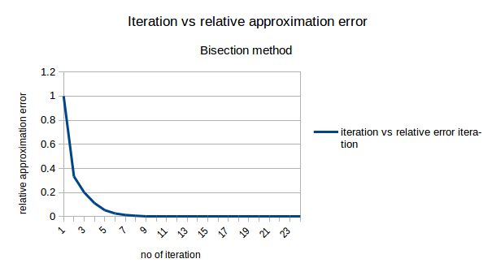
Graph 3: The graph of xr and relative approximation error (false position).
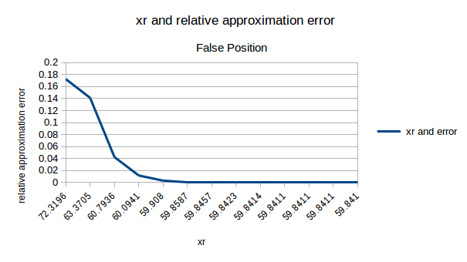

Graph 4: The graph of no of iteration and relative approximation error (false position).
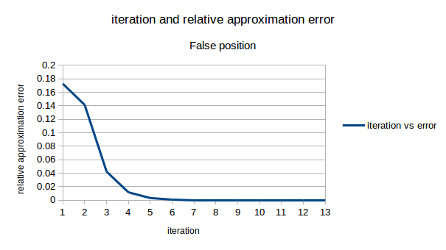
Graph 5: Compare the relative approximate error with respect to number of iteration between the bisection method and false position method.

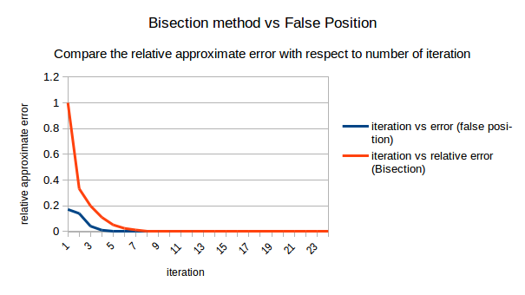

Graph 6: Compare the relative approximate error with respect to x

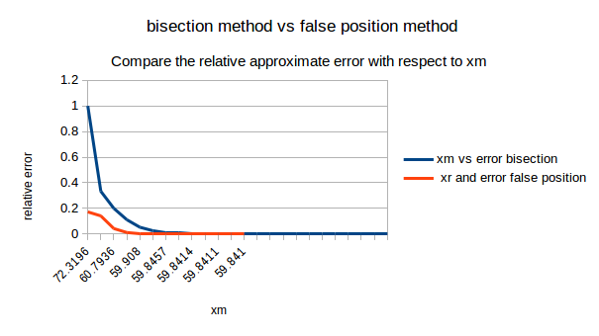
Problem 2
(a) Use the Newton-Raphson method to determine a root of f (x) = −x2 + 1.8x + 2.5 using x0 = 5.
(b) Use the Newton-Raphson method to find the root of
f (x) = e−0.5x (4 − x) − 2
Employ initial guesses of (i) 2, (ii) 6, and (iii) 8.

Solution:
#include<bits/stdc++.h>
using namespace std;
double f10(double x)
{
double r= -x*x + 1.8*x +2.5;
return r;
}
double f11(double x)
{
double r= -2*x +1.8;
return r;
}
void print(double v1, double v2, double v3, double v4, double v5)
{
cout<< "|" << setw(15) << v1 << "|" << setw(15) << v2 << "|" << setw(15) << v3 << "|" << setw(15) << v4 << "|" << setw(15) << v5 << "|" <<endl;
for(int i=0; i<80; i++)
printf("-");
puts("");
}
void print(string v1, string v2, string v3, string v4, string v5)
{
cout<< "|" << setw(15) << v1 << "|" << setw(15) << v2 << "|" << setw(15) << v3 << "|" << setw(15) << v4 << "|" << setw(15) << v5 << "|" <<endl;
for(int i=0; i<80; i++)
printf("-");
puts("");
}
double f20(double x)
{
double r= exp(-0.5*x) * (4-x) -2;
return r;
}
double f21(double x)
{
double r= -exp(-0.5*x) - 0.5 * exp(-0.5*x) * (4-x);
return r;
}
void Newton_Raphson(double initGuess, double input_tolerance, int cs)
{
double x0, tolerance;;
x0=initGuess;
tolerance=input_tolerance;
double x1=x0,rError=1000;
print("iteration", "xi", "f(xi)", "f'(xi)", "Relative error");
int cnt=0;
while(rError>=tolerance)
{
x0=x1;
double r0,r1;
if(cs==1)
{
r0=f10(x0);
r1=f11(x0);
}
else
{
r0=f20(x0);
r1=f21(x0);
}
print(++cnt,x0,r0, r1,rError);
if(r1==0)
{
printf("Causing division by zero hence terminating\n");
return ;
}
x1= x0 - r0/r1;
rError=fabs((x1-x0)/x1);
}
printf("root=%.6f\n",x1);
}
int main()
{ printf("Maximize the screen\n");
printf("Newton-Raphson:\n1st equation: root of f (x) = -x^2 + 1.8x + 2.5\n");
printf("Input tolerance:");
double tol;
cin>>tol;
printf("Initial root: 5 tolerance:%.6f\n\n",tol);
Newton_Raphson (5,tol,1);
puts("");
puts("");
printf("2nd equation: root of f (x) = e^(-0.5x) (4 - x) - 2\n");
tol=0.0001;
printf("Initial root: 2 tolerance:%.6f\n\n",tol);
Newton_Raphson (2,tol,2);
puts("");
puts("");
printf("Initial root: 6 tolerance:%.6f\n\n",tol);
Newton_Raphson (6,tol,2);
puts("");
puts("");
printf("Initial root: 8 tolerance:%.6f\n\n",tol);
Newton_Raphson (8,tol,2);
puts("");
puts("");
}

Sample Input:
Input tolerance:0.00001
Sample Output:
Snapshot 1:
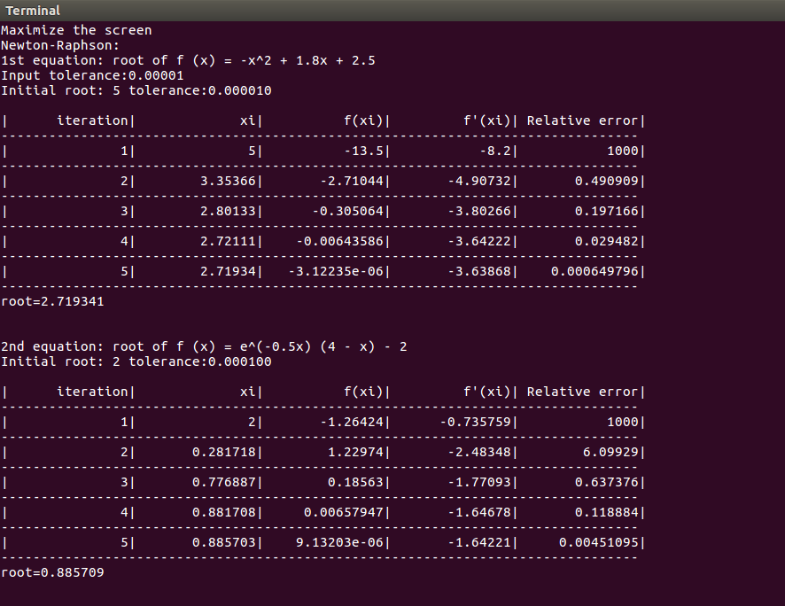
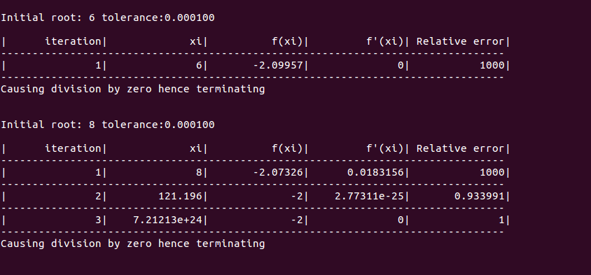
Snapshot 2:

Problem 3
(a) Consider following easily differentiable function,
f (x) = 8 sin(x)e–x − 1:
Use the secant method, when initial guesses of xi–1 = 0.5 and xi = 0.4
Solution:
#include<bits/stdc++.h>
using namespace std;
double f(double x)
{
double r1=8*sin(x)*exp(-x)-1;
return r1;
}
double find_point(double x0, double x1)
{
double r1,r2;
r1=x0*f(x1) - x1*f(x0);
r2= f(x1)-f(x0);
return r1/r2;
}
void print(double v1, double v2, double v3, double v4, double v5, double v6)
{
cout<< "|" << setw(15) << v1 << "|" << setw(15) << v2 << "|" << setw(15) << v3 << "|" << setw(15) << v4 << "|" << setw(15) << v5 << "|" << setw(15) << v6<< "|" <<endl;
for(int i=0; i<100-4; i++)
printf("-");
puts("");
}
void print(string v1, string v2, string v3, string v4, string v5, string v6)
{
cout<< "|" << setw(15) << v1 << "|" << setw(15) << v2 << "|" << setw(15) << v3 << "|" << setw(15) << v4 << "|" << setw(15) << v5 << "|" << setw(15) << v6<< "|" <<endl;
for(int i=0; i<100-4; i++)
printf("-");
puts("");
}
int main()
{
printf("Maximize the screen\n");
double x0,x1,x2;
x0=0.5, x1=0.4;
double rError=1000,tolerance;
printf("f(x)=8sin(x)e^(–x)− 1\n");
printf("Use the secant method, when initial guesses of xi–1 = 0.5 and xi = 0.4\n");
printf("Input tolerance:");
cin>>tolerance;
x2=x1;
x1=x0;
print("iteration", "Upper value", "Lower value", "Xm", "f(Xm)", "Relative error");
int cnt=0;
while(rError>=tolerance)
{
x0=x1;
x1=x2;
x2= find_point(x0,x1);
rError=fabs((x2-x1)/x2);
//printf("iteration=%d Upper value=%.4f Lower value=%.4f Xm=%.4f f(Xm)=%.4f rError=%.6f\n",++cnt,x0, x1,x2, f(x2),rError);
print(++cnt,x0, x1,x2, f(x2),rError);
}
printf("root=%.4f\n",x2);
}

Sample Input:
Input tolerance:0.00001
Sample Output:
Snapshot 1:
